**DAILY ONLINE ACTIVITIES SUMMARY**

|  |  |  |  |  |  |  |  |  |
| --- | --- | --- | --- | --- | --- | --- | --- | --- |
| **Date:** | **8-6-2020** | | | | | **Name:** | **Prajna** | |
| **Sem & Sec** | **8th sem ‘B’** | | | | | **USN:** | **4AL16CS067** | |
| **Online Test Summary** | | | | | | | | |
| **Subject** | | **SMS** | | | | | | |
| **Max. Marks** | | **60** | | **Score** | | | **54** | |
| **Certification Course Summary** | | | | | | | | |
| **Course** | **Introduction to front end** | | | | | | | |
| **Certificate Provider** | | | **Great Learning** | | **Duration** | | | **30min** |
| **Coding Challenges** | | | | | | | | |
| **Problem Statement:**1**.** Write a c program to program to reverse the characters of string. | | | | | | | | |
| **Status: Completed** | | | | | | | | |
| **Uploaded the report in GitHub**  **GitHub link:** | | | | | **Yes**  **https://github.com/alvas-education-foundation/prajna_k** | | | |
| **If yes Repository name** | | | | | **prajna_k** | | | |
| **Uploaded the report in slack** | | | | | **yes** | | | |

Online Test Details: (Attach the snapshot and briefly write the report for the same)

Certification Course Details: (Attach the snapshot and briefly write the report for the same)

Coding Challenges Details: (Attach the snapshot and briefly write the report for the same)

1)online test

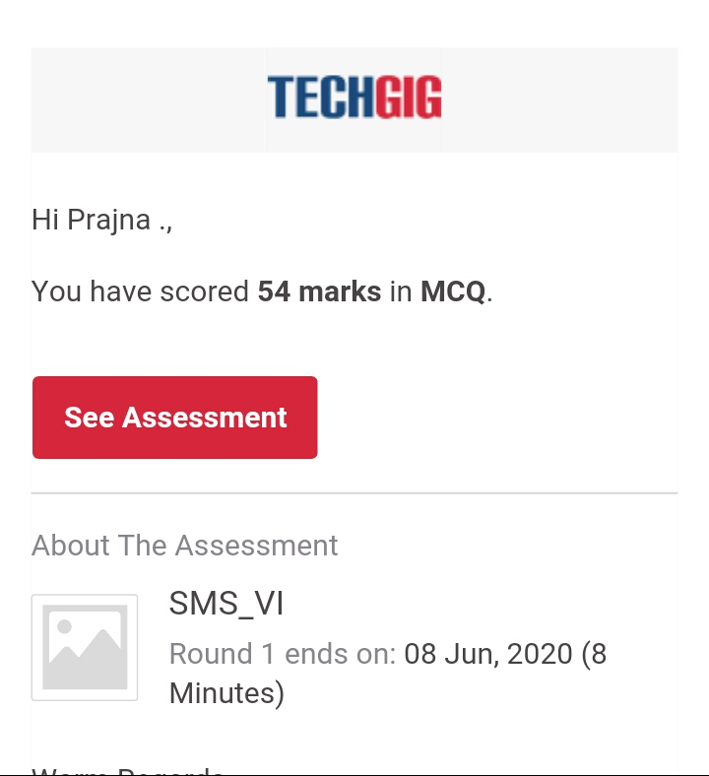

2) certification course

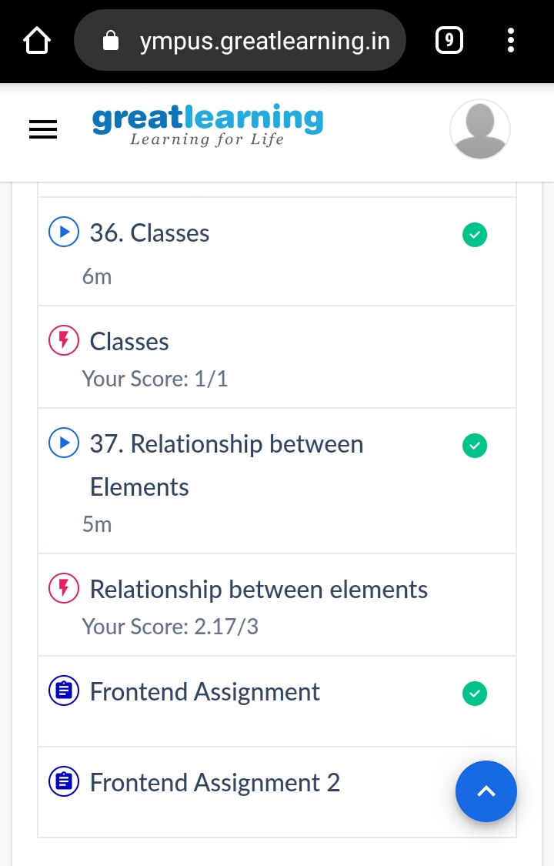

3) coding challenges

Program 1

#include <stdio.h>

#include <string.h>

#include <stdlib.h>

void main()

{

char str[100];

int l,i;

printf("\n\nPrint individual characters of string in reverse order :\n");

printf("------------------------------------------------------\n");

printf("Input the string : ");

fgets(str, sizeof str, stdin);

l=strlen(str);

printf("The characters of the string in reverse are : \n");

for(i=l;i>=0;i--)

{

printf("%c ", str[i]);

}

printf("\n");

}

|  |
| --- |
|  |
|  |  |
|  |  |
|  |  |
|  |  |
|  |  |